F007-LOGIN

Case 1: Login successful

+ Testing steps:

step 1: m2m-clothing\scr\main\ resources\ templates\Front_End

step 2: Find the sign-in.html file

step 3: Right click and select open file

step 3: Log in successfully and go to the home page form

+Illustration

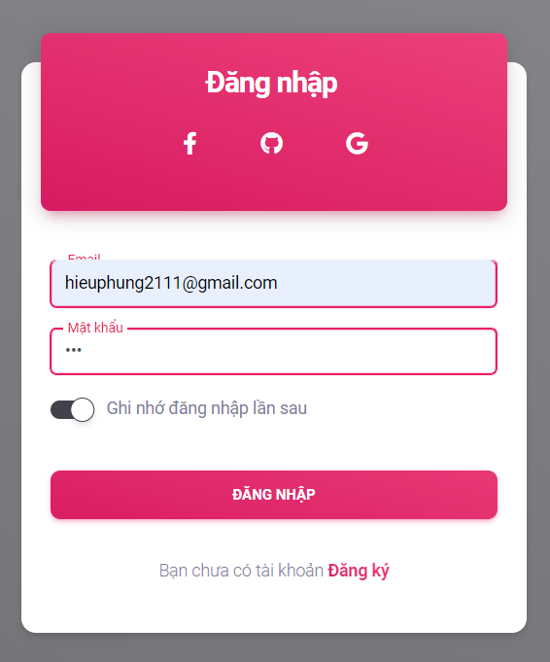

Case 2: Login failed

+ Testing steps:

step 1: m2m-clothing\scr\main\ resources\ templates\Front_End

step 2: Find the sign-in.html file

step 3: Right click and select open file

+Illustration

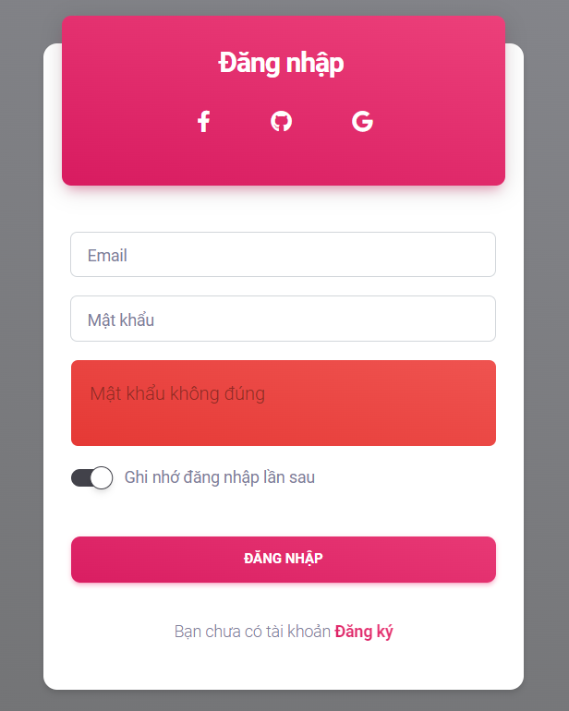

Case 3: Confirm OTP forgot password successfully

+ Testing steps:

step 1: m2m-clothing\scr\main\ resources\ templates\Front_End\pages\

step 2: Find the ConfirmPassword-Forgot.html

step 3: Right click and select open file

+Illustration

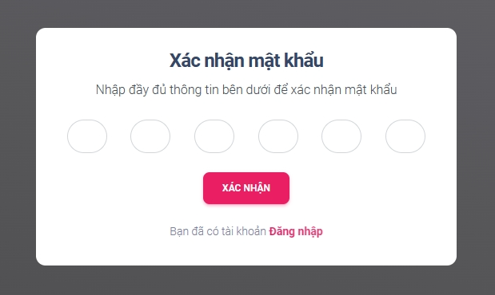

Case 4: Confirm OTP forgot password failed

+ Testing steps:

step 1: m2m-clothing\scr\main\ resources\ templates\Front_End\pages\

step 2: Find the ConfirmPassword-Forgot.html

step 3: Right click and select open file

+Illustration 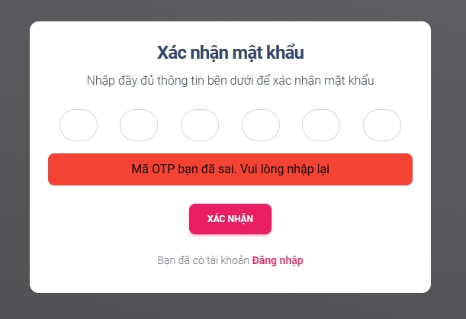

Case 5: Confirm forgot password successfully

+ Testing steps:

step 1: m2m-clothing\scr\main\ resources\ templates\Front_End\pages\

step 2: Find the ConfirmPassword-Forgot-mk.html

step 3: Right click and select open file

+Illustration

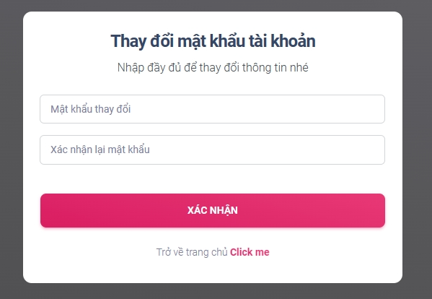

Case 6: Confirm forgot password failed

+ Testing steps:

step 1: m2m-clothing\scr\main\ resources\ templates\Front_End\pages\

step 2: Find the ConfirmPassword-Forgot-mk.html

step 3: Right click and select open file

+Illustration

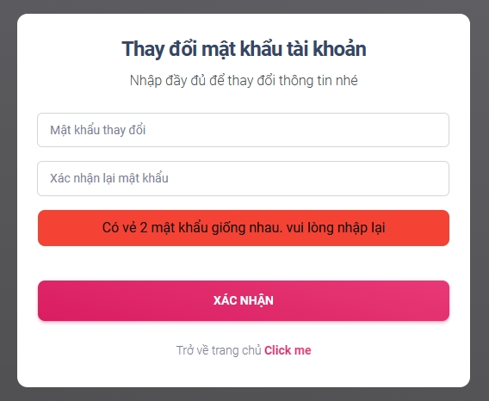

Case 7: Confirm OTP registered successfully

+ Testing steps:

step 1: m2m-clothing\scr\main\ resources\ templates\Front_End\pages\

step 2: Find the ConfirmPassword-signup.html

step 3: Right click and select open file

+Illustration

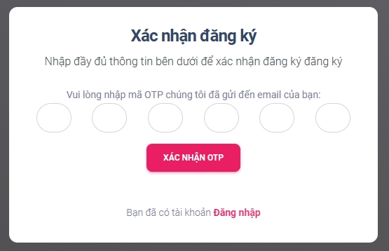

Case 8: Confirm OTP registered failed

+ Testing steps:

step 1: m2m-clothing\scr\main\ resources\ templates\Front_End\pages\

step 2: Find the ConfirmPassword-signup.html

step 3: Right click and select open file

+Illustration

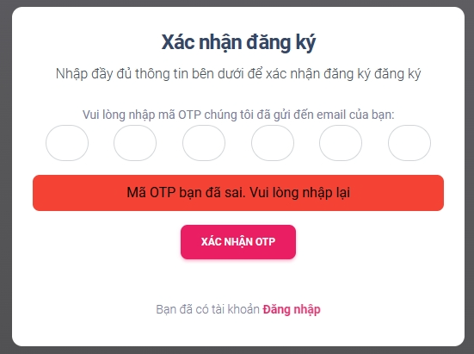

Case 9: Password changed successfully

+ Testing steps:

step 1: m2m-clothing\scr\main\ resources\ templates\Front_End\pages\

step 2: Find the changePassword.html

step 3: Right click and select open file

+Illustration

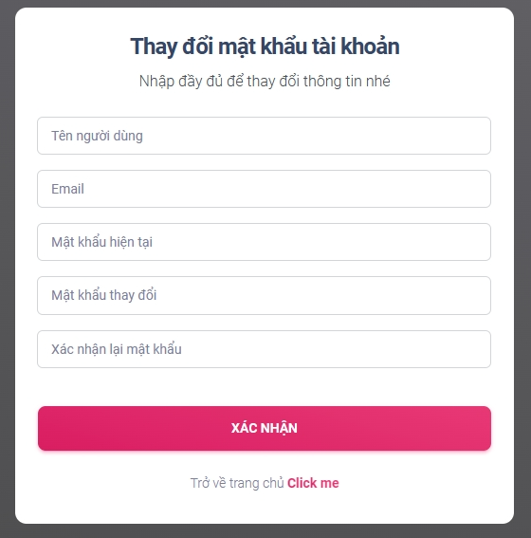

Case 10: Current password is incorrect

+ Testing steps:

step 1: m2m-clothing\scr\main\ resources\ templates\Front_End\pages\

step 2: Find the changePassword.html

step 3: Right click and select open file

+Illustration

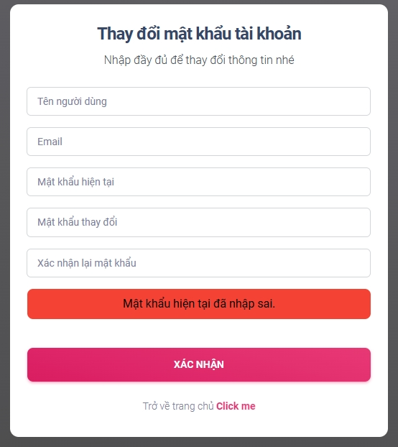

Case 11: Password changes are not the same

+ Testing steps:

step 1: m2m-clothing\scr\main\ resources\ templates\Front_End\pages\

step 2: Find the changePassword.html

step 3: Right click and select open file

+Illustration

